Nordic Sustainable Development
Indicators – in the light of Agenda 2030
Johan Bring, Statisticon, johan.bring@statisticon.se
Ulla Agerskov, Nordic Council of Ministers, ullage@norden.org

Abstract
Undoubtedly, the Nordic countries are in the global elite when it comes to being closest to achieving many of the Sustainable Development Goals (SDGs) by 2030. Across international analyses the Nordic countries consistently score in the top 10. Despite this, successful implementation of the SDGs will require that the Nordic countries also understand their shortcomings in relation to the 2030 Agenda. A good understanding of shared challenges can foster strong collaborations across the region on how to overcome them.
To monitor the Nordic region’s progress towards sustainable development, the Nordic Sustainable Development Indicators were introduced in 2013. These 22 indicators show long-term trends within the following focus areas: the Nordic welfare model, viable ecosystems; changing climate; sustainable use of Earth’s resources; and education, research and innovation.
In September 2017, the Nordic countries adopted a joint programme for the implementation of 2030 Agenda under the title “Generation 2030”. After the adoption of the programme, a mapping between the Nordic Sustainable Development Indicators and the SDG Indicators was carried out. The mapping was finished in Spring 2019 and will serve as a basis for discussions on the needs for adjusting or supplementing the Nordic Sustainable Development Indicators in the nearer future.
Keywords: Nordic co-operation, Sustainable Development, 2030 Agenda, SDGs, indicators

1. Nordic Council of Ministers and sustainable development
Strategy on sustainable development
The Nordic Council of Ministers has worked with sustainable development since the end of the 1990s. The Nordic strategy for sustainable development, A Good Life in a Sustainable Nordic Region, is the overall framework for the Council of Ministers' work. All work carried out within the Council of Ministers will incorporate a sustainability perspective.
The strategy provides long-term guidelines as far as 2025 and aims to promote the cross-sectoral work of the Nordic Council of Ministers in the following focus areas: the Nordic welfare model, robust ecosystems, climate change, sustainable use of the earth's resources, as well as education, research and innovation
The Ministers for Co-operation have the overall responsibility for Nordic inter-governmental work on sustainable development. They have set up a Nordic Expert Group for Sustainable Development to assist in the follow-up work on the Nordic Council of Ministers’ sustainability strategy 'A Good Life in a Sustainable Nordic Region' and the Nordic Council of Ministers’ work to implement Agenda 2030.
The Nordic Strategy for Sustainable Development is the overriding and cross-sectoral framework for the work of the Nordic Council of Ministers – and is in line with the ambitions and goals of the 2030 Agenda
Indicators for sustainable development
To follow the Nordic Region’s progress towards Sustainable Development, the Nordic countries have agreed on a set of Nordic indicators. The existing Nordic Sustainable Development Indicators were introduced in 2013 and show long-term trends in the above-mentioned focus areas.
These indicators are regularly updated and published online in Nordic Statistics Database - nordicstatistics.org/nordic-sustainable-development-indicators. They were also – until recently – displayed at Nordic Council of Ministers website. The dissemination on the web-site is currently under revision.
Finally, the indicators were published in the publication Nordic Sustainable Development Indicators 2014 (NCM 2014) as part of the launch of the indicators. The development and maintenance of the indicators has been led by Statistics Denmark and is now being updated by Statisticon, a Swedish company, which from 2018 is in charge of coordinating the Nordic Statistics for the Nordic Council of Ministers.
Adoption of the Generation 2030 programme
In 2017, the Ministers for Nordic Co-operation adopted the Generation 2030 programme for the period 2017–2020. The programme is an element in the overall strategy on sustainable development mentioned above. The programme will facilitate co-operation on the challenges faced jointly by the Nordic countries in achieving the UN’s Agenda 2030 and its 17 sustainable development goals (SDGs).
The Nordic Council of Ministers has no formal role in the follow-up of Agenda 2030, but the Nordic Council of Ministers aims to support the Nordic countries in their work on Agenda 2030. This is done within the framework of the Nordic Generation 2030 program (NCM 2017B).
By the adoption of the Generation 2030 programme, the Nordic expert group found it relevant to review the present Nordic sustainability indicators in the light of the 2030-Agenda. Statisticon was commissioned to perform this task in the form of a pilot study with a specific focus on indicators connected to SDG 12 (Sustainable consumption and production).
The purpose of the review has been to serve as a guide for the Nordic Council of Ministers (NCM) in its future use of statistics monitoring sustainable development and is partly based on interviews with the Nordic statistical institutes. The report was presented to the Nordic expert group on sustainable development in April 2019 and some of the central findings are listed below. The expert group has not yet recommended a future development of the Nordic sustainable development indicators.
2. Analysis
2.1. The Nordic sustainable development indicators
The Nordic sustainable development indicators show long-term trends in the following focus areas: the Nordic welfare model; viable ecosystems; changing climate; sustainable use of the earth’s resources; and education, research and innovation. The focus areas reflect the overall strategy of sustainable development in the Nordic cooperation.
The Nordic sustainability strategy is however mainly focused on collaboration and other qualitative aspects and is in general not formulated in terms of measurable targets. Examples of goals under the focus areas in the Nordic Strategy are:
- ”Scientific results will be used more often as the basis of decisions relating to formulation of policies.”
- ”Extended Nordic collaboration regarding research for green growth, welfare and health”.
- ”Quality and security in the social and health sectors will be strengthened.”
The Nordic sustainable development indicators listed in figure 1 are not clearly connected to the goals in the strategy (www.nordicstatistics.org/nordic-sustainable-development-indicators). Hence, there is no clear link between the goals formulated in the strategy and the actual indicators used.
2.3 Criteria for good indicators
Another thing to consider in relation to the revision is the quality and applicability of the indicators. There is a vast literature on how to develop and chose indicators, see e.g. EAA (2014), Brown (2009), Niemeijer and de Groot (2008), Penchenon (2008). In the international comparison of countries with respect to Agenda 2030 the following criteria are used in Bertelmann Stiftung (2018):

- Global relevance
- Statistical adequacy
- Timeliness
- Data quality
- Coverage

Indicators should in general have a desired direction or a specific target. Therefore the decision to use a specific set of indicators is in a sense a political statement, which is also the case with the sustainable development indicators which are approved by the ministers of cooperation. The determination which indicators to use in the Agenda 2030 was also a result of a long and difficult process. A possible way to avoid this challenge would be for the Nordic Council of Ministers to just publish statistics related to sustainable development without labelling the presented data as indicators.

Figure 1, The Nordic indicators for sustainable development - focus areas and main indicators
The Nordic welfare model
- Demographic trends
- Gross Domestic Product (GDP)
- Public debt
- Urbanization
- Employment and unemployment rate
- Life expectancy at birth
- Gini-coefficient
- Risk of poverty amongst families with children
- Gender pay gap

Viable ecosystems
- Sustainability of fish stocks
- Discharge of nitrogen and phosphorus into the Baltic Sea
- Change in the common bird index
- Developments in annual fellings and increments in forests
- Urban population exposure to air pollution by ozone and particulates

Changing climate
- Share of renewable energy in gross energy supply
- Developments in greenhouse gas emissions by sector
- Emissions and land use, land use change and forestry

Sustainable use of earth’s resources
- Decoupling of environmental pressures and economic growth
- Nordic Ecolabel and the EU Ecolabel
- Proportion of environmental taxes in total tax revenues
- Development in municipal waste management by treatment method
- Education, research and innovation
- Educational attainment Research and development expenditure as a percentage of GDP

Education, research and innovation
- Educational attainment
- Research and development expenditure as a percentage of GDP

2.2 Mapping of the Nordic indicators with Agenda 2030
By the adoption of the Generation 2030 programme, it seemed relevant to consider how the Nordic sustainable development indicators are in sync with the Agenda 2030 indicators. A mapping was carried out in the pilot project to investigate how the indicators in the Nordic strategy related to the 17 SDG goals in Agenda 2030. In Figure 1 the classification of the Nordic indicators is to the left and the associated SDG in Agenda 2030 is to the right.
Figure 2, Mapping of the Nordic sustainability indicators to the seventeen SDG:s in Agenda 2030. (Indicators that do not match to any SDG are labelled as ‘none’ to the right in the figure.)
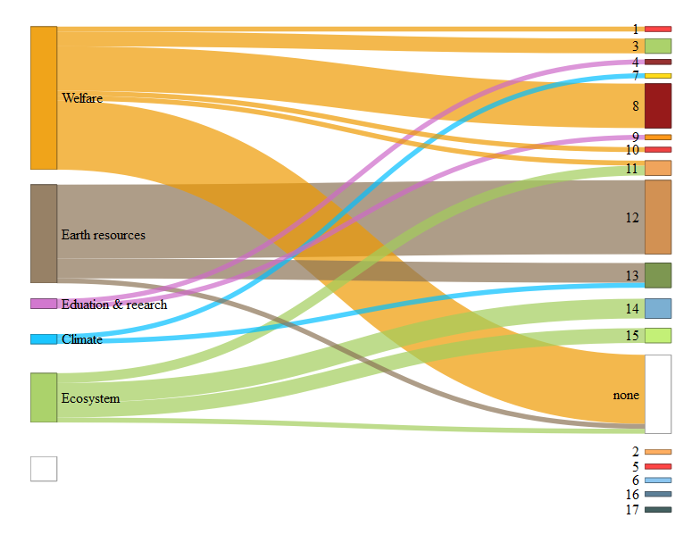
Nordic sustainable development indicators indicators
SDG:s in Agenda 2030
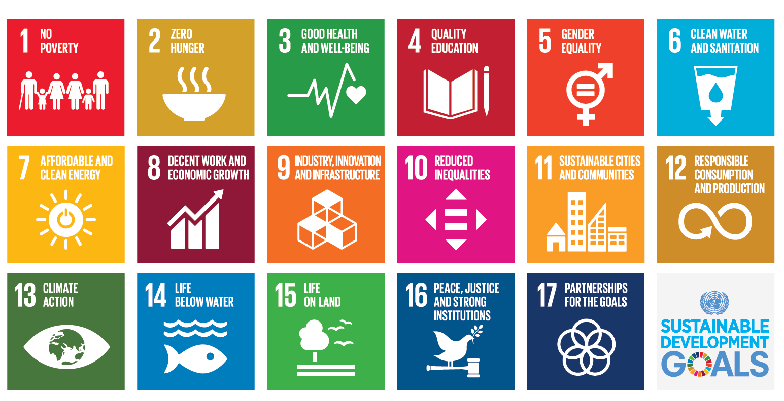
Three conclusions can be derived from this mapping.
- Most Nordic indicators are in the areas of welfare and earth resources.
- Many of the welfare indicators do not match directly to any of the Agenda 2030 SDGs (labelled ‘none’ to the lower right corner).
- Many of the SDGs in Agenda 2030 only have one or zero corresponding indicators in the Nordic indicator set.
Hence, using the present set of Nordic indicators to follow the Nordic countries progress according to Agenda 2030 does not seem to be a viable approach.
2.4 Focus area – SDG 12: Sustainable consumption and production
The Nordic countries rank high in international reports of nations' progress towards the 17 Sustainable Development Goals (SDG). Along with other industrialised countries, however, the Nordic countries have been ranked poorly in their progress towards SDG 12, which concerns Sustainable Consumption and Production. An area where the Nordic countries do not excel is in SDG12, sustainable consumption and production, see e.g. NCM (2018). Hence, SDG12 is chosen as an important area for the Nordic Council of Ministers work around sustainable development – and as a focus point in the pilot project performed by Statisticon.

Figure 3, Nordic progress on SDG12
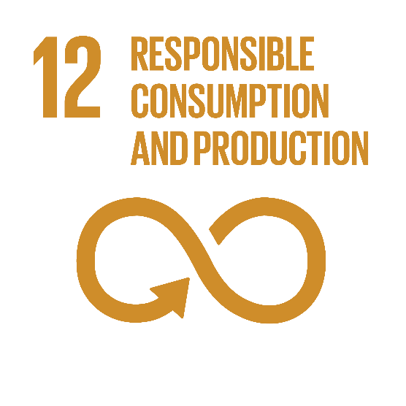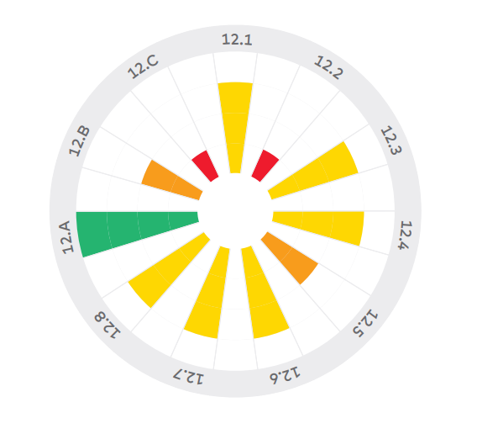

For the UN-indicators in SDG 12, there is unfortunately not much data available. Hence, at present it is difficult to use the specific indicators suggested in the Agenda to monitor the progress on goal 12. Many international organizations publish indicators in relation to Agenda 2030. In table 2 we compare the indicators used by:
- UN’s indicators for SDG 12
- Eurostat’s indicators for SDG 12
- SDG index and dashboards report 2018
- Atlas of Sustainable Development Goals 2018
Table 1, Indicators used in international comparisons to monitor SDG12 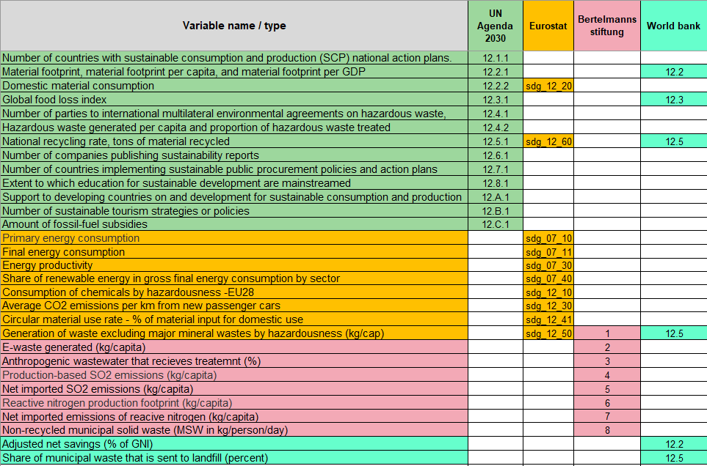
Some of the indicators are similar, but still there is a surprisingly low overlap between the indicators used to monitor SDG 12. Hence, there is currently little international agreement how to monitor the development in SDG 12.
When a country or organization should develop indicators there is a question of how close these indicators need to be to the suggested UN-indicators? An argument for staying strict to the UN-definitions could be that otherwise there is a risk to diminish the impact of Agenda 2030. If each country, in reality, has its own indicators there is less opportunity for comparison and there is a risk of choosing indicators for a specific purpose.
Examples of indicators to the left are, of course, UN's own indicators. Another example is the indicators published on Statistics Denmarks’s SDG portal, which are in line with UN definitions. On the other side of the spectrum, Finland states that in the long term they will publish so-called "proxies", where they will produce indicators that can be assumed to be close to those specified by the UN, but not identical. Sweden has in SCB's report SCB (2017) also proposed a set of indicators that are not identical to the UN's but can be assumed to be reasonably close.
Thus, the proposed national follow-up is relatively tightly linked to the agenda's sub-goals. Of course, there are important areas and challenges that relate more or less clearly to the agenda. However, to relate the national follow-up to the main target level would require considerably more trade-offs in terms of relevance SCB (2017).
There are shared opinions on the benefits of making a freer interpretation of the UN's goals and choice of indicators when a country is to produce its own indicators. One advantage is that the indicators can be more relevant and specific to a country’s special conditions. One disadvantage, on the other hand, is that there is a risk of "watering down" the agenda if each country chooses its own definitions and own indicators. As an example of an indicator set further to the right, Eurostat indicators are linked to Agenda 2030. For each of the 17 target areas, Eurostat has selected 5-6 indicators – and some indicators fit into several different goals. A total of 5-12 indicators are listed for each target. Many of these indicators differ from the indicators selected by the UN. However, they have a certain connection to the UN's overall objectives. Eurostat calls its indicators "SDGs in an EU context".
An argument for not adhering so strict to the original definitions is a better availability of data and the possibilities of indicators monitoring more country-specific areas that might not be adequately covered by the UN-indicators.
The Nordic countries do have different approaches to, how close to the Agenda indicators need to be. Some prefer to publish indicators if they exactly correspond to the definition provided by UN while other countries have a more liberal approach.
As could be seen in table 2 there is already a considerable discrepancy regarding which indicators to use to monitor SDG 12. A relevant question is if the Nordic Council of Ministers should promote the development of other indicators for this SDG? Two arguments for providing specific Nordic indicators could be:
- Areas where the Nordic countries have more and better data than many other countries in the world. Then the Nordic countries could be in the forefront in the development of new world indicators.

- Areas where there are specific situations in the Nordic countries not covered by the international UN indicators.

An example of the first is the Environmental accounts where the Nordic countries have come very far, NCM (2016). In SCB (2016) Statistics Sweden presents a specific set of indicators suggested to monitor SDG 12. This is an example of a suggestion of indicators that do not adhere strictly to the definitions of the UN indicators.
An example of indicators specifically relevant for the Nordic region are e.g. indicators related to the environmental situation in the Baltic sea or the use of the ecolabel ‘Svanen’.
Table 2, The Nordic countries' access to data to calculate UN indicators within target 12.
Indicators | Sweden | Norway | Denmark | Finland | Iceland
12.1.1 Number of countries with sustainable consumption and production (SCP) national action plans or SCP mainstreamed as a priority or a target into national policies
12.2.1 Material footprint, material footprint per capita, and material footprint per GDP
12.2.2 Domestic material consumption, domestic material consumption per capita, and domestic material consumption per GDP
12.3.1 Global food loss index
12.4.1 Number of parties to international multilateral environmental agreements on hazardous waste, and other chemicals that meet their commitments and obligations in transmitting information as required by each relevant agreement
12.4.2 Hazardous waste generated per capita and proportion of hazardous waste treated, by type of treatment
12.5.1 National recycling rate, tons of material recycled
12.6.1 Number of companies publishing sustainability reports
12.7.1 Number of countries implementing sustainable public procurement policies and action plans
12.8.1 Extent to which (i) global citizenship education and (ii) education for sustainable development (including climate change education) are mainstreamed in (a) national education policies; (b) curricula; (c) teacher education; and (d) student assessment
12.a.1 Amount of support to developing countries on research and development for sustainable consumption and production and environmentally sound technologies
12.b.1 Number of sustainable tourism strategies or policies and implemented action plans with agreed monitoring and evaluation tools
12.c.1 Amount of fossil-fuel subsidies per unit of GDP (production and consumption) and as a proportion of total national expenditure on fossil fuels

Not available
Data available
Available, but not calculated
Available, but not easily calculated

In the research community there has been a lot of criticism against the commonly used indicators to monitor consumption and production. A common objection is that the indicators focus too much on the end of the production-consumption chain (e.g. Waste management) instead of focusing on reducing the actual consumption volumes, see e.g. Alfredsson et al (2018), Chan et al (2018).
Among the UN indicators for SDG 12 the indicators for food loss (12.3.1) and sustainable tourism (12.B.1) and public procurement (12.7.1) are areas where the Nordic countries could have good opportunities to take a leading role in the development of good international indicators.
Hence, a possible area for the future collaboration between the Nordic countries in the development of indicators could be Nordic statistics on e.g.
- meat-consumption,
- transport
- travel statistics
- and other important consumption patterns.
2.4.2 Challenges
A challenge for a Nordic focus and development of indicators at a Nordic level is that each country prioritizes their development of national indicators and monitoring their own progress. There are also requirements to report to Eurostat, UN and other international organizations. Hence, there is little time and resources to also focus and collaborate at the Nordic level. However, the Nordic NSI:s do collaborate and share experiences regarding indicators related to Agenda 2030 but the main focus is to fulfil the national requirements. There is not a strong focus to e.g. harmonize the definitions between the Nordic countries.
The continuous development and an increased use of the Nordic database, hosted by the Nordic council of ministers, could be a way to enhance a Nordic perspective of suitable indicators. The development and use of the database should also facilitate a harmonization of the definitions of indicators used in the different Nordic countries.
Another way for the Nordic council of ministers to assist the Nordic NSI:s is to produce statistics aggregated at the Nordic level which can enhance the international awareness of the development in the Nordic countries and region.
- Conclusions
In the analysis of indicators used to monitor the Nordic strategy for sustainable development several issues arise. In the first analysis, comparing these indicators with the SDGs in Agenda 2030, it was evident that the two only ‘map’ partially. This is not surprising since the Nordic indicators have a Nordic focus while the Agenda 2030 has a global focus. However, many of the Nordic indicators did not map any of the SDG goals, which could seem surprising since the Agenda 2030 SDG basically covers all areas of sustainable development.
In the study of indicators used to monitor SDG 12, sustainable consumption and production, it was found that different international agencies (and countries) use very different set of indicators. This raised the important issue of how close an indicator needs to be to the original set of UN-indicators to be qualified to be labelled as an Agenda 2030 SDG 12 indicator. If we only use indicators close to the original definitions this will limit the possible data and statistics to use. If there is too much leeway in the choice of indicators it will diminish the comparability - and possibly the impact of the Agenda 2030.
A possible way forward is an observed room for collaboration between the Nordic countries in their work with indicators for Agenda 2030 as part in the development of some of the UN indicators for SDG 12 where the Nordic countries have good data availability and -quality. Another option could be the compilation of additional indicators focusing on actual consumption volumes.
Continue to develop and increasing the use of the Nordic database, hosted by the Nordic council of ministers, could also be a way to assist the Nordic NSI:s in developing and harmonizing sustainable development indicators.

4. References
Alfredsson et al (2018), Why achieving the Paris Agreement requires reduced overall consumption and production. Sustainability: Science Practice and Policy, vol. 14: pp.1-5.
Bertelmann Stiftung and Sustainable Development Solutions Network (2018), SDG Index and dashboard report 2018 – Global responsibilities, implementing the goals.
Brown (2009), Good Practice Guidelines for Indicator Development and Reporting,
Third World Forum on ‘Statistics, Knowledge and Policy’.

Chan et al (2018), SDG 12: Responsible Consumption and Production. A Review of Research Needs. Technical annex to the Formas report Forskning för Agenda 2030: Översikt av forskningsbehov och vägar framåt. Stockholm Environment Institute, Stockholm.

EEA (2014) Digest of EEA indicators 2014, EEA Technical report No 8/2014

NCM (2014) Nordic Sustainable Development Indicators 2014, Nordic Council of Ministers.
NCM (2016) Making the environment count – Nordic accounts and indicators for analysing and integrating environment and economy. TemaNord 2016:507

NCM (2017), Bumps on the Road to 2030 – An overview of the common challenges for the Nordic countries in achieving the Sustainable Development Goals (SDGs) Nordic Council of Ministers.

NCM (2018), Sustainable Consumption and Production – an analysis of Nordic progress towards SDG12, and the way ahead. Nordic Council of Ministers.

Niemeijer and de Groot (2008), A conceptual framework for selecting environmental indicator sets, Ecological indicators 8:14-25.

Pencheon D, (2008), The Good Indicator Guide: Understanding how to use and chose indicators. NHS Institute for Innovation and Improvement
SCB (2016), Monitoring the shift to Sustainable Consumption and Production Patterns – in the context of SDGs. Statistics Sweden.
SCB (2017), Om statistikbaserad uppföljning av Agenda 2030 – Slutrapport av uppdrag till Statistiska centralbyrån om statistikbaserad analys av Sveriges genomförande av Agenda 2030. Statistiska Centralbyrån.
World Bank (2018), Atlas of Sustainable Development Goals 2018: From World Development Indicators.

Bertelmann Stiftung and Sustainable Development Solutions Network (2018)
World Bank (2018)

