Design thinking in developing new concepts for statistical content
Laura Mäkelä, Statistics Finland, laura.makela@stat.fi
Abstract
Service design or human-centered design is becoming the number one method of developing user-oriented services.
In Statistics Finland we are currently in the middle of an overall renewal of our web service. It’s a massive project concerning both the dissemination of statistical content, and the content management and back-end side of data dissemination.
In the project we are exploiting the methods of service design to achieve the goal of making our website more user-friendly.
The presentation will go through the following:
- Design thinking and service design as a tool for developing services
- How to implement service design in developing a web service for a National Statistical Office
  - the Double Diamond of service design as implemented in the renewal of the web service of Statistics Finland
- The findings: new concepts created during the project (so far) and how they differ from the outcomes of previous projects
- Experiences in using service design methods and working with service design consultants
Keywords: Service design, user needs, web services, data dissemination

Introduction
Statistics Finland is aiming at redesigning it’s web service both on the front-end and on the back-end side. The goal is to make our data and services easier to find and use. The service needs to be based on modern and adaptive technical solutions as we cannot foresee all the coming shifts in our society. The service has to be accessible as well as stated by the Finnish law based on EU directive.
Because of the largeness of the task and the complex needs aimed at the coming service, we have taken on design thinking approach in the development process. Here you will have an introduction to design thinking and service design process, and learn some experiences we have to offer.

Design thinking
Design thinking is an approach which is traditionally used in industrial design. During the recent decade it has been implemented more and more in the development of services as well.
Design thinking could be described as a strategic, holistic approach for thinking and acting creatively. It tries to anticipate changes and adapt to them. That’s why design thinking should be a part of every organization’s strategy work. It makes it easier for the organization to change its processes and services in times of change and disruptions.
The key principles guiding design thinking are empathy, co-creation and experimenting.
There are as well three key goals in using design thinking. It should:
- enhance user value and make sure that the products or services are desirable
- ensure feasibility, e.g. verify technical qualifications and guarantee appropriate resources
- keep things viable. On public sector this can be interpreted as making sure that the products/services execute current strategy.

Service design as a framework for development
Service design means innovating, developing and designing services with design methods. It is a creative and practical way to improve existing services and innovate new ones (Stickdorn et al., p, 19, 2018). Service design uses methods from ethnography, information science and interaction design.
These methods are easy to implement in any design and development work, be it refining service processes or designing software, ecosystems or web services.
Service design is all about developing services so that the user is in the center of attention. In service design process, we try to gain real understanding of the needs and challenges of the user. These might be not just work-related needs; life situation, family, hobbies – all affect the user’s needs.

Key principles of service design
Key principles of service design doing are (revised from Stickdorn et al., 2018):
- Empathy, human-centered perspective
- Observation of usage of products/services in real-life situations
- Service touchpoints, service moments and customer journey: recognizing the “moments of truth” i.e. critical success/failure points and visualizing the service journey
- Co-creation with users and collaboration with stakeholders of various backgrounds
- Iterative process: working in a series of repeating, deepening and explorative loops
- Visualization of answers and solutions to problems: sketches, scribbles, wireframes to demonstrate your idea
- Experimenting and prototyping in an early stage (and willingness to fail)
- Concepting and productization: solutions that can be extended and copied to other services
Service design aims at improving the service experience while also catering for business goals. As an outcome of service design process, the services should be relevant for users and competitive for the service provider.

Service design process in developing web services
For the execution of the design process there are different frameworks to utilize. In here I will introduce two of them. It’s worth noticing that there are many others, like the one of human-centered design used by the design firm IDEO.

Strategy as a starting point
The design process should always start with a background work. This includes studying the strategy of the organization at hand. Mission, vision and strategic objectives should be considered before starting the ideation work.
The service designer and project manager (and other key members) should as well be aware of organization’s goals, if they are not explicit in the strategy. These might originate from regulations (like accessibility), from government programmes or from other factors.

The Double Diamond
To have a steady framework for the development process is always a plus. One of these is called The Double Diamond. It is a model for a design process developed by British Design Council in 2005 and illustrated e.g. by Stickdorn et al in This is Service Design Doing (p. 89, 2018). It divides the design process into four phases: discover, define, develop and deliver.
Figure 1: The Double Diamond of Service Design
The Double Diamond helps you to concentrate first on information acquisition regarding the problem you are solving. Then it guides you to define the key challenges users are facing. Then it gives you tools to generate a whole bunch of ideas. And finally, it offers you a framework for concept definition and prototyping phases.
The discovery phase is crucial in finding where the real challenges lie e.g. in the use of a web service. However, the second diamond with the development and deliver phase is usually the more time and resource consuming. It includes building interactive prototypes for the users to try and comment on, the iteration of these prototypes and, importantly, the definition of key elements, functions and technical solutions of the desired service.
We have used the Double Diamond as a guiding framework for service design process in the web redesign project. It has helped us to understand when it is time to ideate and when it is time to define and iterate solutions. Ideation phase can’t last forever, if you want to gain solutions.

Design Sprint
Design Sprint is a special kind of method that is often used as a part of service design process. It is a five-phase, usually a week-long process for rapid prototyping and testing of ideas. It was developed by Google Ventures and has been widely used in product and service design.
The idea is to take one problem or one part of a service to develop and then, in only one week, to gain understanding on the matter, develop creative ways to solve the problem, identify best ideas, build prototypes and test them with users.
Figure 2. Design Sprint illustrated by jthoyer
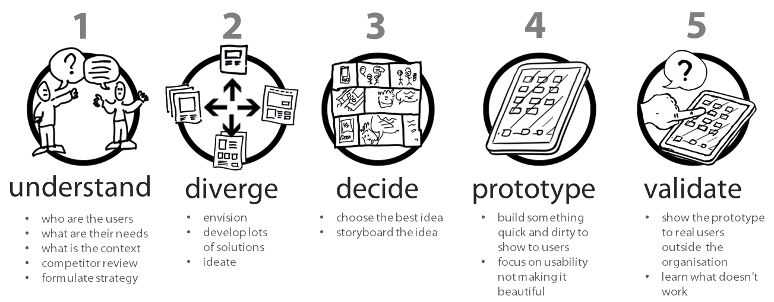
The goal is to test the idea before any real implementation (or coding): Are we on the right track with this solution? Is it relevant to users? Is it feasible technically?
Design sprints are often used in certain phases of design projects. They are most useful when you have a distinct task to tackle.
In our web project we have used one-week design sprints in designing data collection pages and in sketching the home page of our web service. The outcomes and experiences gained in these sprints were highly positive: the participants found the process to be engaging and rewarding. And the end results were as desired: from both sprints we got a clear idea on what we are trying to aim at, be it a friendly and guiding service for data providers or a sense of what our home page could look like.

The Double Diamond in redesigning the web service of Statistics Finland
A couple of years ago Statistics Finland decided to start an overall renewal of its web service. It’s a massive project concerning both the dissemination of statistical content, and the content management and back-end side of data dissemination.
The four goals of the project are:
- Remodel the structure of the web service to better cater for user needs
- Reform the content of the service to adapt to future needs
- Redesign user interface
- Renew publication system to minimize publication errors and to speed up publication process
We have used the Double Diamond in the web site project to sequence the design process into distinct phases with different goals and purposes.
There are four phases in the Double Diamond: discover, define, develop and deliver. Next, I will go through these with concrete examples from the web renewal project.

Discover phase
The discover phase is all about recognizing relevant user groups and understanding the needs and feels of users. In the discover phase we had a year-long project with the aim of finding out the main challenges users face while trying to find relevant data on our website.
Figure 3: The Double Diamond, Discover phase
In this phase we had workshops with different kinds of users. Users were also interviewed and observed regarding the use of our web service. We also made a card-sorting workshop with users where they grouped our statistics into groups or themes they found relevant.
The main goal in this phase is to gain understanding on the initial problem – in our case findability of data – and to understand the user. Empathy is most important. You must let go of your own assumptions and listen to the user.

Define phase
In this phase the goal is to define the problem(s) you are solving. Therefore, you can define the goals for the project or for the design process.
Figure 4: The Double Diamond, Define phase
In the define phase we continued the workshops with users, but also started to analyse our learnings.
In the define phase one crucial outcome is user or customer personas, and these we also produced. We had external consultants helping us with this phase. They as well drew customer paths for each of the main personas. These paths demonstrate the failure points in customer’s journey through our service. These points are the ones that should be addressed first. Fixing them will enhance user satisfaction the most, therefore being the most productive.

Figure 5: The customer personas of Statistics Finland
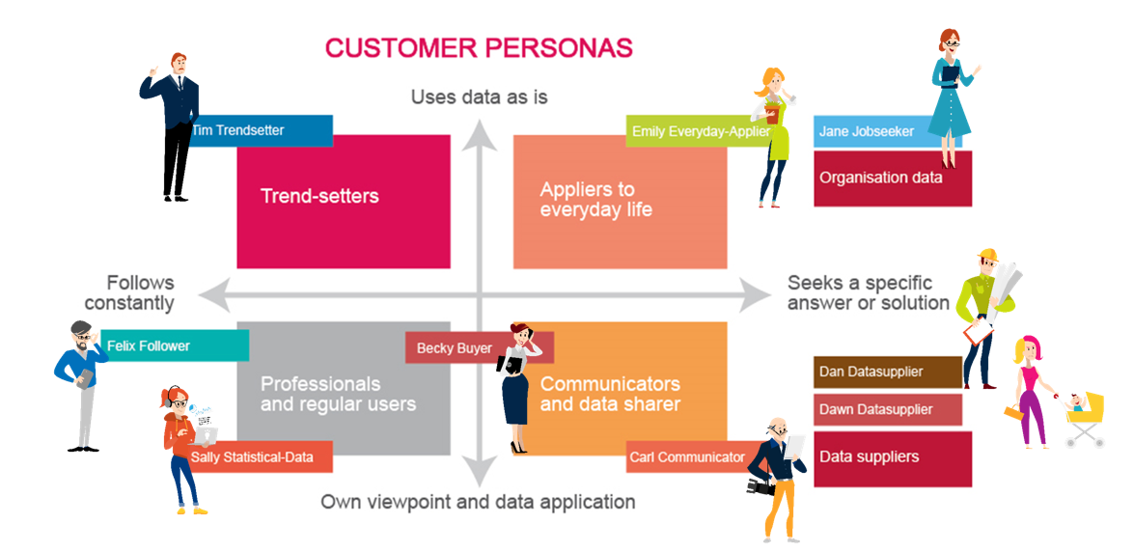

We defined our so-called design drivers (or principles for the redesign of the service) to be: findability, desirability, accessibility and service-orientation.

Develop phase
When we had defined our goals for the renewal process, we continued to the develop phase.
In this phase the goal is to produce as much new and revolutionary ideas as possible: solutions to problems, new content concepts, new service ideas and functions. It is recommended to look for analogies in other fields.
For example, we took online shops like Zalando and observed how they have organized their products under different categories: which are the main categories, how are sub-categories divided, are there categories overlapping (i.e. does the same product appear in different categories) and what are the search functions and filters.
We started new projects when entering this phase. First ones were the content and production projects that lasted just a few months. These were mainly discovering ways to work and collaborate. The actual, longer content and prototyping projects started in February 2018.
Figure 6: The Double Diamond, Develop phase and different projects of the web renewal project
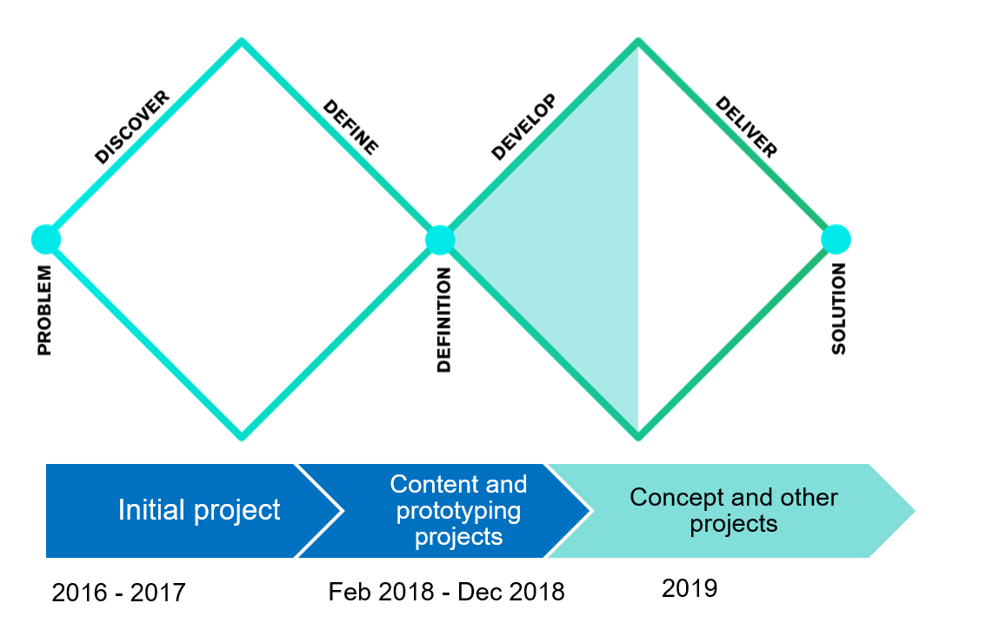
Two content projects (numbered as project 1 and project 2, creatively) generated ideas for both the statistical content pages and for the data collection pages. Based on the sketches and drafts produced in content projects, the production project then went on to design prototypes. The prototypes were then tested on users and iterated accordingly.
The develop phase is, in my opinion, the most fun and rewarding. You get to brainstorm, do Crazy Eights (Figure 7) and ideate in all possible ways. In the content project 1 we produced a bunch of new ways of presenting statistical data.
Figure 7. Crazy Eights exercise: produce 8 ideas in 5-8 minutes
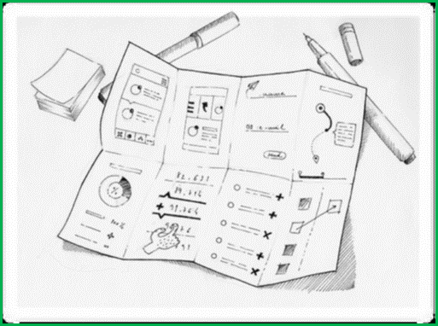

Deliver phase
In the deliver phase the goal is to choose, from all the great ideas you have produced, the ones that work best with the users and the ones that are most feasible.
Figure 8: The Double Diamond, Deliver phase
This is the phase where you have to be more realistic. In our website redesign we are now in this phase, and it can be described as tedious. We are defining the elements and functionalities in detail. All the time there is popping up new fragments of content or metadata that needs to be defined.
Fortunately, there is a clear purpose for all the definitions: we produce clear concepts for the statistical content. These concepts are then used in prototyping of the new sites, in producing pilots with real data and text, and finally, in beta coding.

New concepts for the dissemination of statistical content
During the previous content projects and the ongoing concept project, we have ideated several new ways of representing the data. These ideas wouldn’t have seen the light if we would have worked using more traditional ways of innovation, I think. The facilitation methods used in service design boost ideation and brainstorming, and as well support the hard part, that is, selecting the best ideas and discarding others.

Modules and blocks as basic elements
One of the innovations made in the content and concept projects was building the service from modules and blocks. These are construction elements, “bricks”, that the service is constructed from.
Modules are once produced and then used multiple times in different parts of the service. The key figure module (figure 9) is saved from database table and composed in the management system. The module includes sharing and saving functions, as well as a link to the source table in our database. The module can appear in a statistical release, in topic pages and in phenomenon pages.
Figure 9. Example from a key figure module
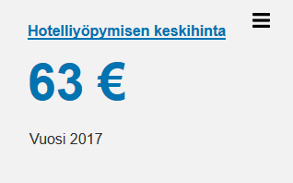
Modules compose blocks and blocks compose pages. In the new web service, we don’t make pages anymore. We make content. Content that is distributed and re-used in different parts of our web service.

New statistical releases
The core content of our web service are the statistical releases, which we nowadays publish around 560 times per year.
In these, the new concept model brings on new modules and elements.
There will be so called bullet points, that highlight the most interesting changes in the statistical data in question.
Figure 10. Example of bullet points (in Finnish)
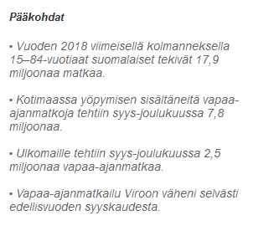
There will as well be a key figure (see figure 9) on all the releases where it is relevant.
Our video team has produced videos explaining the most important issues in releases. In the new web service, these videos may be attached to the release, which is not the case at the moment.
Figure 11. Example of a release video (in Finnish)
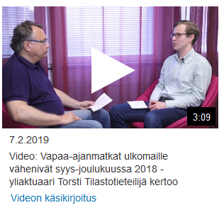

New topic pages
Nowadays our topic pages are just full of links to statistics home pages. In the new model, the topic pages offer users data on the topic: key figures, latest articles and releases plus links to databases on the topic. There will be links to services and training on the topic as well.
All this content will be modular, so that the page uses modules and blocks that are produced for some other pages (mostly statistical pages) beforehand.
The role of the topic page is to function as a navigation path to specified topics, to statistical pages and to the releases. New idea is that each statistic can belong to several topics. Nowadays each statistic is part of only one topic, which makes it harder for users to find relevant data.
Figure 12. Prototype of the topic page on Transport and Tourism (in Finnish)
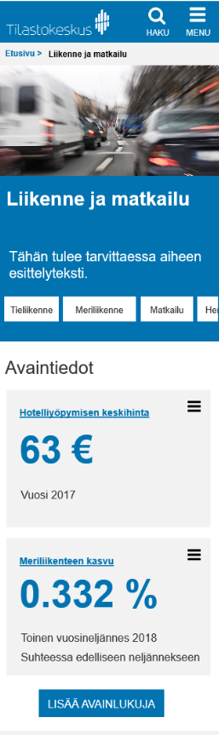

Phenomenon pages
Topics are more stagnant than phenomenon, which will be recognized from social media and from public debate. Also government programme, special years (as was the 100th year of Finland’s independence) and sparse social events like elections, can all be food for statistical phenomenon.
Phenomenon can be more or less short-lived: they can last for some months or some years. The content offered on phenomenon pages will mostly be gathered from already published (i.e. ready) content: articles, statistical releases, videos, key figures etc.
The gathering of this content will reveal if there is a need to produce some fresh blogs, articles, videos, figures etc. on the subject. This makes phenomenon pages dependent on resources. If Statistics Finland is able to automate and lean the production of statistical releases, there will be better resources for building the pages.
Figure 13. Prototype of the phenomenon page on elder care (in Finnish)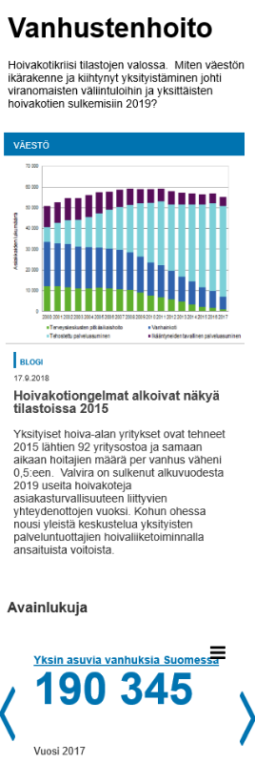
Both phenomena and topics are cross-statistical. They’re roles differ: topics are for gathering statistics and for navigation, phenomena are for offering food for thought for public debate.
Phenomenon will be active as long as it’s alive: when the debate slows down, the phenomenon page can be put aside into archive.
This new concept of offering the users both topic and phenomenon pages is one of the things that was caused by well-facilitated workshops – and thus could be seen as the outcome of using service design methods.
Both these types of new content require editorial teams: to construct the topic pages, to recognize relevant phenomenon and to identify content relevant to them. The formation of these editorial teams fosters the building of new kind of professional roles for statisticians and other experts in the organization.

Learnings
Service design was used already in the initial project that formulated the design goals and user personas for the coming projects to use. So, it was a predetermined setting when we started the content projects in 2018.
I had myself learned service design in an online course of IDEO while taking a maternal leave from work. So, I was more than happy to notice that service design was taken into use in my organization when I got back.
When the content projects 1 and 2 started in 2018, we already had external consultants to facilitate workshops (using service design methods) for us. When the contract with that partner ended, we, project managers, started facilitating workshops ourselves. This was laborious but rewarding and educational for us.

Co-working as a team of several projects
Collaboration is essential part of (service) design process. It means co-creating ideas with the users. But equally important is the co-working with the own staff. All relevant stakeholders should be included in the ideation and define phases. Piloting with real data is also an important chance to include relevant experts in your organization.
Since this is a large project consisting of several projects, it is vital that we have weekly planning session among us managers. We plan which tasks to take on in this sprint (of 2 weeks), what communications activities there should be and what are we bringing for the steering group to decide on. It is important to do the right things at the right time, not in any order possible.

Communicating the service design project
Information sharing and spreading on the project is the most challenging part for us, I think. There should be a balance between hearing everyone and being inclusive and being reasonably cost-effective and fast.
If you have workshops with every unit of the organization, you might end up with a lot of work on organizing the workshops, and with too many contradicting opinions.
We have chosen to communicate in intranet through blogs and news, and by organizing meetings with development managers. Most importantly, our design project teams consist of experts from different units and disciplines, which brings on multiple views on subjects.

Experiences of using service design consultants
We’ve had experiences with several service design consultants so far. They all have been helpful and competent in different ways. Some have been more visual and documentation-oriented, others better at facilitating workshops and at keeping up the tempo.
The most important finding regarding this aspect might be that it’s wise to take in all the tips and tricks from consultants, and to try facilitating the workshops by yourselves. Service design methods are easy, you just have to learn them and be brave to use them.

What next?
After the new site has been available for users in beta for a while, we will go on to production phase. The production will, most likely, be gradual, so that some parts are taking into production first, and then step by step the other ones. The first parts taken into production will be the statistical pages (topic pages, statistics pages, releases) and the home page of Statistics Finland. Other parts will follow later.
This gradual approach has been popular in web renewals of other countries as well, such as Canada.
We surely will continue using service design in some of our design projects (design meaning the development of new services and the refinement of existing ones).
This said, I think that Statistics Finland is in so called design ladders on the stage 2 or 3, where design thinking is only used in certain projects. We should aim at step 4, where it’s integrated in our processes. Better yet, design thinking could be a part of strategic thinking in management level.

Why to use service design methods in developing web services?
There are several advantages in using service design methods in website redesign or other service projects.
First, you get to make sure you tackle real problems. In the service design process, you gain knowledge on the problems users are facing and identify the key elements to make them happier. This enables you to solve the right problem, not just solving the problem right.
Solving the right problems (instead of just solving the problems you have identified yourself) leads to better user value. And, at the end, it might even enhance the quality of life of your customers.
Second, all the iteration in the process leads to increased usability and accessibility. Before, it was common that organizations like us designed a new service by arranging the elements/offerings in a way they assumed to be relevant to users.
For example, in Statistics Finland we had new aggregated data we wanted to offer to users, like data by postal code area. We then assembled a cross-organizational team of statistical experts, IT-professionals and communicators to sketch the web pages for the service. Then the sketch was circulated on management meetings and maybe shown to some users for comment. There was some refinement before coding, but mostly that was it.
Now we’ve had multiple iterations on the prototypes based on user testing. This is largely because we have adopted an approach of making the first prototypes in an early stage of design process. The main idea is to iterate, make better, the prototypes step-by-step, not getting the right outcome at first round.
When you make sure that your service is easy to use, it leads to happier and more autonomic users. The customer experience is better, and even productivity might grow as help-desk costs are reduced.
And third, using service design most likely leads to a well-designed product. This brings more value for customers, which means larger revenue or (in the open data world) more use for your data and improved brand image for your organization.
Since at Statistics Finland we are still at the experimental phase with using service design, any productivity or user satisfaction growth is not yet to be proven. But, what we can state is that the collaboration between experts from different fields has been very successful. Working in the web design project has been rewarding to the participants, which they have stated themselves multiple times.
The experience we’ve had from using service design is that it helps us to move from endless discussions and opinions to building prototypes, testing them and improving them. “Show me, don’t tell me”, as they say in Stickdorn et al., p. 3.

Disadvantages?
I was asked if there are any disadvantages using service design methods. One thing to consider is that service design process can take longer time than the common ways of developing products or services. But since the outcome is, most likely, more in line with the real problems users are facing, the process is more productive compared to making services that are almost but not quite right.

Is it usable for other than web design projects?
Service design is widely used in the design of different tangible services like hospital and other healthcare environments in Finland, as well as commercial services like clothes stores and restaurants. In these the customer journey through the facilities and the service moments are crucial.
Service design has been implemented in the Prime Minister’s Office in Finland as well. They’ve had a project for constructing Opportunities for Finland report, which supports governmental decision making.
They have also stated that using service design and sprints has helped the co-creators to concentrate on the work at hand, be more productive, focus on bigger picture and concepts instead of details. And the co-creators felt the experience to be more rewarding and positive than in normal working groups or brainstorming sessions.

References
Danish Design Center: The Design Ladder. Available at: https://danskdesigncenter.dk/en/design-ladder-four-steps-design-use (Accessed: 28 June 2019)
IDEO.org: DesignKit Methods. Available at: http://www.designkit.org/methods (Accessed: 28 June 2019)
Stickdorn, M., Hormess, M., Lawrence, A. and Schneider, J. (2018). This Is Service Design Doing. 1st ed. Sebastopol, Canada: O'Reilly Media Inc.

http://www.designkit.org/methods
Danish Design Center: The Design Ladder

