Experiences of mobile first articles and blogging service

Maija Metsä, Special Editor, maija.metsa@stat.fi
Abstract
Today, reliable fact-based stories are more crucial than ever. This paper presents the key observations and impacts of the digitalisation process of print periodical (Tieto&trendit), published by Statistics Finland. As a result already in 2018 we published alltogether 59 articles and 48 blog posts – observing various topics – to advance better understanding of statistics and also reaching larger audience via social media. The new mobile first publishing concept is based on user experience, retrievability, visuality and linkability. It offers needed degrees of freedom and courage to interactive communication of statistical community.
Keywords: Communication, digitalisation, mobile publishing concept, articles, blogging
(1)
- Introduction – dealing with “post-truth problem”
The societal questions of our time – climate change, globalization, immigration flows, political turbulence with the rise of populism and “post-truth” politics – are all very complex requiring fact-based information and analysis for decision-making. At the same time informational digital environment is characterized by information (as well as misinformation) overflow and fragmentation as anyone can comment, share, publish, edit and republish information.
At the ISI’s 61st World Statistics Congress (16-21 July 2017, Marrakech) Enrico Ciovannini (former Chief Statistician of the OECD) argued that the “post-truth problem” will explode in the future”. To stay relevant statistics – and statisticians – must, in his view, serve as a “humble man” bridging the gap between the fake truths and truths.
In this context, we need to ask ourselves: How do we compete in post-truth world? How do we stay relevant, visible and influential in today’s digital environment? How to reach and convince larger audiences with compelling fact-based stories in the future?
Statistics Finland is mainly seen as reliable and impartial information provider. However, in today’s complex world we anticipate in our new strategy increasing need for fact-based information and covering also new topics in a form that serves different target groups. According to the vision of our new communication strategy, launched to support the new strategy of Statistics Finland, we are seen, besides opinion leader with courage, also fast and proactive.
This paper aims to highlight our experiences as well as some key observations and impacts of the digitalization process of our print periodical, underlining the process how the new article and blog website has managed to offer needed degrees of freedom and courage to digital communication of statistical community.
- Background and key objectives
We have a long tradition of article publishing at Statistics Finland, first in printed publications and later some articles have been published also on the web. Various topics have been covered in numerous in-depth articles by numerous experts. Due to this tradition our statistical experts have relatively advanced analytical skills for viewing the society based on the data. In addition, they know well the concepts, restrictions and metadata related to “their statistical data”. The competence arisen from article writing was thus in our use while the project for the digitalisation of Statistics Finland's “Facts&trends” (Tieto&trendit) periodical was set up in March 2016.
Various objectives were set to the new web service publishing articles and blog posts – the main ones being the following:
- To advance effectiveness (incl. increasing familiarity and visibility) of Statistics Finland
- To promote the use and understanding of statistical data as well as fact-based decision making
- To be active in topical communication
These objectives go well together with the mission statement of the new strategy of Statistics Finland launched in 2019: “We bring reliable and up-to-date information for the benefit of customers and into social debate.”
3. Putting customers at the centre
As in the strategy of Statistics Finland, we focused on the customers and first studied our readers' views on the printed periodical and the state of our website (articles and blog posts) already in 2016. The results of the survey to the readers of the printed periodical were intensified by focus group interviews (carried out in September 2016), in which 15 subscribers to the periodical took part. The interviewees were longstanding subscribers to the publication or its predecessors, active users of statistical data and experts by their profile.
According to our customers there is a special demand for reliable analytical articles based on the expertise of statistical professionals, new viewpoints relative to basic reporting of official statistics and good stories supported by good graphics. Interactive infographics was also seen as important tool, in particular, if containing analysis.
The interviewees thought a well marketed web service would bring a larger readership for the content. It was assessed that the website would enable faster reaction to topical social discussion, offer the benefits of links serving readers and a platform for desired use of interactive infographics. The threats were seen as possible “thinning” and shortening of contents, readers being lost under the flood of information, challenges presented by the mobile subscription and website marketing. As a solution, a service like a monthly newsletter was suggested. Website was also expected to be mobile readable. (See annex 1. SWOT analysis of the focus group interviews conducted in September 2016)
- New mobile first publishing concept

The new publishing concept is based on user experience, retrievability/accessibility, visuality and linkability. The transfer from print periodical into web service took place in January 2018 and the renewed website (www.stat.fi/tietotrendit/, see the picture 1.) was launched in May 2018. The new website was built on mobile first technology enabling also new digital communication openings and experimenting. Through valuable links to the users the new website serves also as a portal to the statistics pages.
The website was designed to meet the European Union Directive on the Accessibility of Websites and Mobile Applications requiring EU member states to make sure their websites and mobile apps meet common accessibility standards. The accessibility of Tieto&trendit website was acknowledged with special label already in August 2018.
4.1. Contents of the new publishing concept
The new publishing concept contains:
- in-depth articles analysing and interpreting topical issues and trends based on the most recent statistical data, and trying also to combine statistical data from different sources in order to give more comprehensive picture of our society
- blog posts: connecting with a topical or otherwise compelling matter; pursuing an impact in social debate with viewangles and arguments based on statistical facts. (see the picture 2. for an example on topical matter)
- other content: data visualizations, infographics, videos or other experimental content dealing with versatile topics
Our experts write in the blog, as in the articles, always in their own name and they are responsible for their own writings. This is told clearly in the description of the website and also at the end of each blog post. Today, roughly 95 experts have either brought their views to broader discussion in the form of blog post or produced in-depth analytical articles.
The target set for the publication frequency on the website was one content (article or a blog post) per week, on average. However, the number of contents has gone beyond expectations since the transfer: in 2018 altogether 59 articles and 48 blog posts were published on the website. This year, by the end of June, we’ve already published 36 articles and 40 blog posts. It seems as blogging is becoming more and more popular among our experts. Blog post has proved to be a fast communication channel with which to react to topical discussion and/or correct misuse or misinterpretations of statistics in public (“damage control”) – and to have an impact in social debate.
Articles and blog posts have concerned various topical subjects and themes, such as public expenditure, corporate and capital taxation, inflation, prices, housing, employment, low pay work, education, R&D, innovations, entrepreneurship, challenges of declining birth rates and population structure, immigration, the use of big data, climate change, sustainable development/ SDG indicators, statistics on sexual minorities etc.
Picture 1. Front page of the website publishing articles and blog posts (www.stat.fi/tietotrendit/)

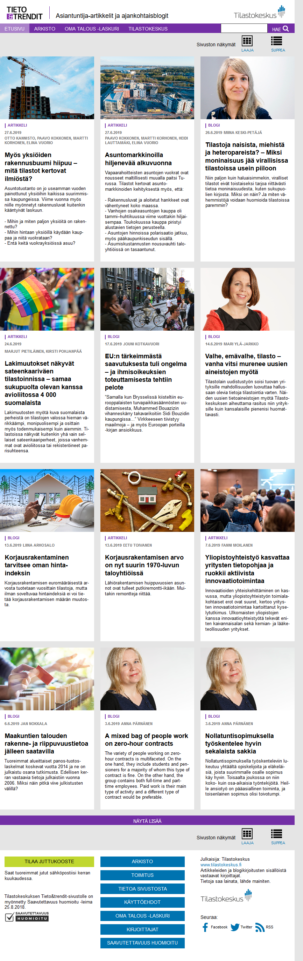

Picture 2. Blog post published on 3rd of June, both in Finnish and in English: “A mixed bag of people work on zero-hour contracts” by Anna Pärnänen, Senior Researcher at the Population and Social Statistics Department at Statistics Finland www.stat.fi/tietotrendit/blogit/2019/a-mixed-bag-of-people-work-on-zero-hour-contracts/

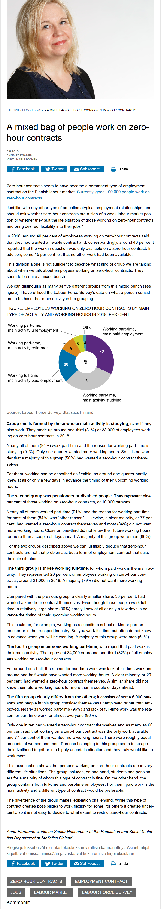

The subscribers of our former print publication have been guided to the web service by offering a monthly Tieto&trendit review, with headlines, leads and links to the latest articles and blog posts, emailed ten times a year. Currently there are around 580 subscribers, consequently more marketing measures and efforts, e.g. in social media, are needed.
4.2. Experiences of the use of social media
The optimally wide visibility, knowledge and effectiveness of the web articles and blog posts require constant and efficient promotion in social media channels used by Statistics Finland (Facebook, Twitter, LinkedIn, Instagram). By employing various social media channels with distinct key messages, our stories can reach different target groups or even larger audiences in various channels, depending on the content and communication objectives (an example in picture 3.)
Picture 3. Example of an article, published on 8th of January 2019, reaching comparatively large audience on Facebook (most likes, shares and comments of our contents so far). Topical article deals with the effects of value-added tax on people with the lowest income.

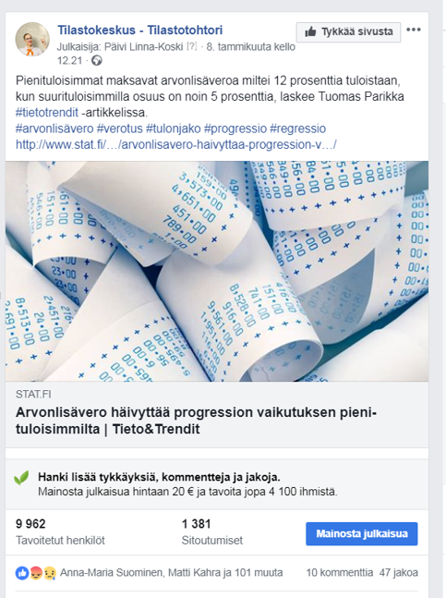

Numerous articles and blog posts have been commented on in the media web news with direct links to our contents, or on social media channels. Articles or blog posts on most appealing or timely topics have formed network-type discussion on social media channels (e.g. on Twitter) and supplemented and corrected the data published by each other, for the benefit of readers.
Just recently, during the Helsinki Pride week, we published an article as well as a blog post, both dealing with statistics – and reasons behind lack of statistics – on sexual diversity and minorities. The article publishing the most recent statistics on the „rainbow families” achieved good media visibility (6 media hits). Both contents were also among the most popular posts on our Instagram account during the Helsinki Pride Week.
The nature of the discussion on social media channels have been gratifyingly versatile and supported the expert profile of the service. Questions have been asked from the writers, data or their reliability have been inquired, challenges have been made and alternative interpretations have been provided and various views have been given.
Being active on social media also means the readiness for replying fast to pertinent reader comments and taking actively part as well as being proactive in social debates. As a result, Statistics Finland’s effective communication is reinforced.

5. Key observations and impacts
The whole digitalization project was launched by asking the readers, outlining the new publishing concept in the digital world based on their views. That step was crucial in the process, and it certainly payed off; the new website has so far been a success. It has met the expectations set for it and even exceeded them with positive media visibility and feedback on social media and in-house.
The articles and blog posts have strengthened Statistics Finland's effectiveness by bringing forward the organisation's expertise in digitized communication of our time. With a blog post it’s possible to react fast, which enables “damage control”. Expert’s voice is heard instead of faceless organisation.
Effective and discernible blogging certainly requires „courage muscle”, having in mind that consideration on ”politically hot topics” pays off. In particular, topical, observant and important topics (e.g. immigration, environmental issues, employment) have notably reached the media and brought visitors to the blog. It seems as blogging persuades new writers from Statistics Finland's younger generation of statisticians and inspires then to examine statistics in the social context and strengthens their expertise.
The strength of the new web service is the variety of topics, writers and writing styles. This requires, however, enough editorial resources with up-to-date expertise in digital communication. It also means focusing on journalistic approach searching for various different angles to the topics, in order to attract the interest of the audience in the middle of the information owerflow. The key messages of the stories must be understandable and relatable to the readers – speaking with people’s voice is vital.
In the future, our aim is to focus on quality, rather than quantity, telling our readers even more compelling stories. Potentially we will attract more new, younger audiences for statistical data by more common sense stories with insightful and humoristic column-like manner. Alongside individual statistics, we certainly need more collected information on topics describing society from different viewpoints that help those needing information to understand society.
At this point it’s ever more essential to measure the effectiveness of the articles and blog posts based on constant tracking. It’s crucial to listen to the customers' needs and expectations and sharpen our communication with respect to objectives, chosen target groups and social media channels.
In order to do so, educating your own staff to proactively react and communicate in today’s digital “post-truth ”world pays off.

Annex 1. SWOT analysis of the focus group interviews conducted in September 2016
How they see the publication and its web transfer?

Strengths:  - Analysis based on the expertise of statistical professionals  - Reliability – Distinguished from fluff information  - Interesting and versatile contents with new viewpoints relative to basic reporting of Statistics Finland  - Stories supported by good graphics differ from others | Weaknesses:  - The website and blog not yet so well known  - Too few international comparisons

Opportunities:  - To strengthen Statistics Finland’s educational role  - To extend the readership; particularly to decision-makers  - To clarify the editorial line and method (e.g. neutrality and participation in social discussion)  …and more opportunities on the web:  - To react fast to topical social discussion  - Own newsletter or RSS feeds by theme/keyword  - Linkability essential  - Interactive infographics containing analysis | Threats (in the web transfer):  - Contents become thinner and shorter  - Due to flood of information readers may disappear  - Selective reading (stories beyond one’s own field are not read)  - Challenges of a mobile subscription and website marketing  - Graphs should be clickable separately (and linked to the data) on the web

“Blog posts are not official views of Statistics Finland. Experts write in their own name and are responsible for their own posts”.

