Proactive presswork – during national election and in general
Magnus Nørtoft, Journalist, nmt@dst.dk
Helle Harbo Holm, Head of Press, hso@dst.dk

To stay visible and relevant as a trustworthy provider of facts to the public debate Statistics Denmark (SD) has developed a proactive leg in the presswork over the past few years.
The proactive presswork is centered around an editorial setup, where the external news flow is monitored, and we actively contribute with relevant data to the topics being discussed here and now. We now have daily meetings, which are open to the entire organization, with focus on today’s stories in the press, and we have a day-to-day production of articles, fact sheets and SoMe posts in direct relation to the news flow.

After two years we have established a solid routine that works for Statistics Denmark, and we think we have succeeded in fulfilling our strategical vision, which is to be “visible and relevant in the public debate”. We have done so with limited resources and most important of all with our credibility intact.

The next national election in Denmark will be held before nsm2019. In Statistics Denmark we have decided to continue the proactive presswork and daily input to the public debate during the period of election. As a part of our preparation for the election, we have published a number of fact sheets on the topics we expect will be among the most debated in relation to the election.

On nsm2019 we will share our experience with:
- Transforming the presswork from reactive to proactive and show examples of our work.
- Proactive presswork during the national election in May/June 2019.
- User reactions, both positive and negative

We also hope to discuss how far we can go on the proactive path as NSIs.

Key words: Presswork, communication, relevance, visibility, election, public debate, fake news, strategy

Introduction
The marked of facts is changing rapidly these years. Organizations of interest and think tanks have become mass producers of data, and they push hard to make their numbers visible in the public debate to try to affect the agenda.
Data is quickly and widely spread through social media, web media and Google – just to mention some of the publication channels. Today, journalists are no longer critical gatekeepers of what is published, as everybody can publish and share whatever data and information they want in seconds. This makes a breeding ground for fake news and alternative facts.
At the same time, the working conditions for the journalists has changed a lot. In most media the editorial desks on specific topics have been merged to one common news desk, which means the journalists are no longer specialists but generalists. Furthermore, the demands to deliver more news articles have increased. All together this makes it easier for organizations with special interests and others to push their data to the journalists, and it makes it less likely that journalists actively go to the National Statistical Institutions’ (NSI’s) websites to search for data.
The NSI’s DNA is to produce facts and data and make it available for the public. But given the circumstances described above, it is time to consider if the NSI’s should expand the role and play a more active part in the public debate, if we want to maintain our role as the preferred provider of facts.

Background
In SD we have already made the choice to be more visible and proactive in the public debate. Thus, it is a strategic goal for the coming years to transform the institution into an extrovert data- and knowledge generator, which strengthens the common understanding of societal phenomena.
The starting point to a more proactive presswork in SD was Strategy 2020 (now 2022) where it is a goal that Statistics Denmark should play a more active role in the public debate.
To support Strategy 2020 a number of substrategies were written. One of them was the Communication and dissemination strategy in which the overall strategy was translated into a dissemination context.
Under the Communication and Dissemination strategy there are a number of detailed strategies with specific plans of action. One of these strategies is the Press strategy. A specific initiative in the Press Strategy was to setup of an editorial desk where the external news flow is monitored, and we actively contribute with relevant data to the topics being discussed here and now.
This means there is a clear connection from the overall strategy to the specific initiative in the press strategy.

The proactive presswork
Every workday at 10:00 pm an open editorial meeting is held in Statistics Denmark. This meeting is a cornerstone in the proactive presswork in SD. Before the editorial meeting, a journalist from the press unit has monitored the daily press and identified stories that lack facts. A list of these usually 3-4 stories are e-mailed to all employees in SD. At the meeting, the aim is to clarify what figures SD have available or might be able to create and if these figures are fit for use in the specific context in the public debate.
Apart from the editor on duty several other employees from different division of SD are present (see diagram below). The head of press (output editor) and the input editor (senior employee from the analysis unit) are always present. The output editor decides to which stories we proactively contribute and how we publish the relevant figures. The input editor is evaluating the possibilities and limitations in SD’s data. The rest of the press team and local “press officers” from different statistical units can also be present at the meeting. The local press officers work as linkage between the press unit and the statistical divisions bringing highly specialized insights to the meeting.
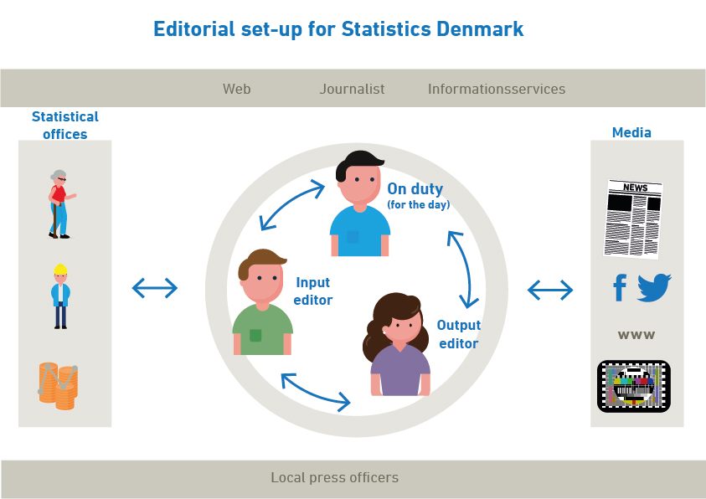
Criteria for entering a story
Entering a story with figures and facts are based on three criteria:
- The news criteria
- The quality of data
- The value we can add
SD enters stories that score high on the news criteria importance, timing, relevance, identification. Evaluating the news criteria is a specific focus in selecting the stories before the daily editorial meeting.
Evaluating the quality of data in this context is evaluating if the quality of data is “fit for use” in this specific context.
The value we can add to a high extend depends on whether figures on the topic already exists in the public debate – e.g. from another stakeholder.
It’s important to clarify these things as early as possible in the process. The input editor and the local press officers play key roles in this part of the editorial work.
The institutions core values are reflected in the editorial work: Independence, objectivity, quality. This implicates that SD is very clear about the criteria for when we decide to proactively push data on a subject. Another implication is that we don’t look at who has a political interest in the story and who could benefit from the results of our data.
If all the criteria above are met and we have the resources to give a story priority we publish the figures regardless of what they might show. That being said we try to be aware not only to work on stories caused by statements or suggestions from the government.
Resources
To implement the proactive presswork the press unit has acquired one extra employee and re-organization in the dissemination division has add two extra journalists. Since 2018 the press unit has consisted of four journalists and one student. The proactive leg in the presswork is only a part of the tasks solved by the press unit.
Publication channels
The channels we chose for publication depend on the content. Almost everything is presented on Twitter. Sometimes – usually if the numbers are already published – we publish nothing but a twitter post with a short text, a figure and a reference to the source. Sometimes we dig a bit deeper and make a fact sheet, and sometimes we write a news article. Now and then a topic is so complex yet important we decide to write an analysis to shed light on it.
See all tweets on our profile: @dstdk
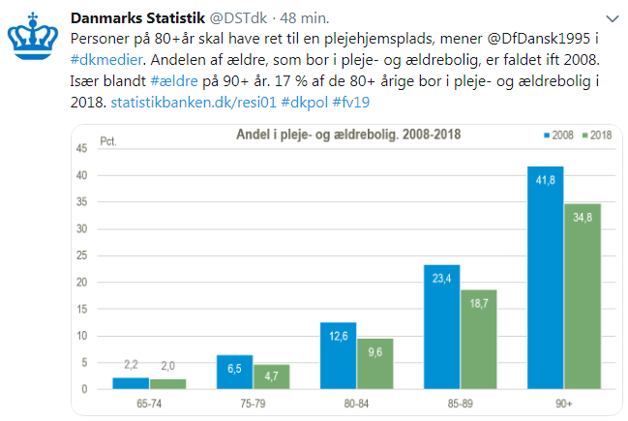
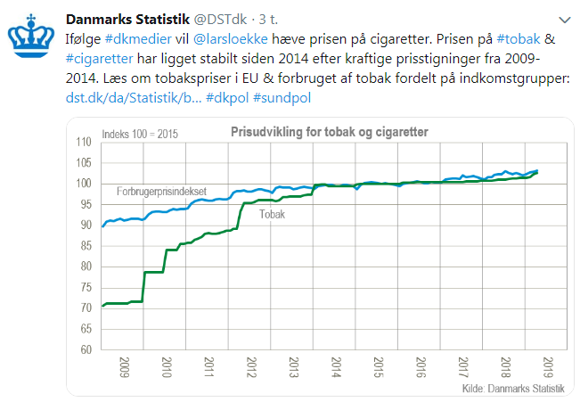
See articles and fact sheets on our website: www.dst.dk/bagtallene
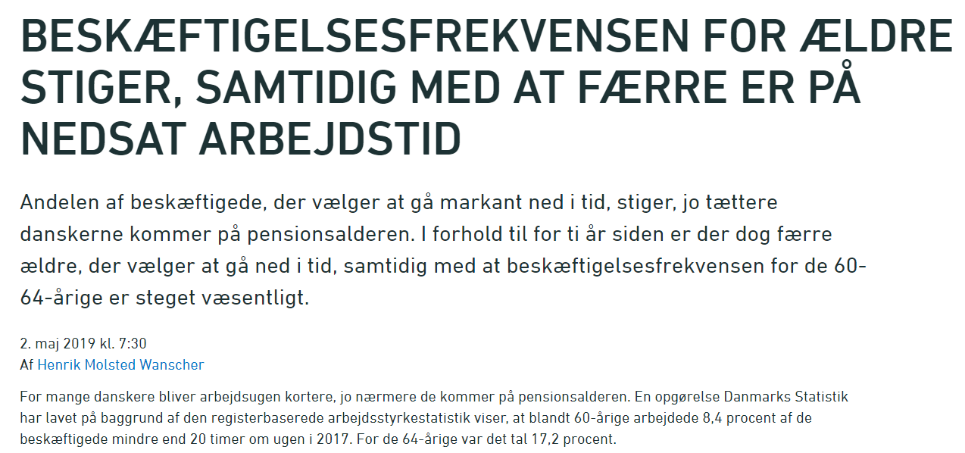
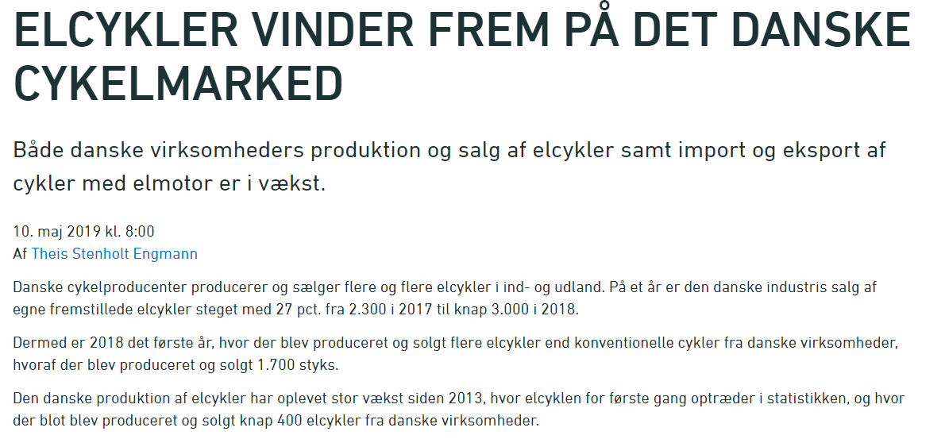
During 2018 SD has published about 80 articles and fact sheets and about 400 tweets as a part of our proactive press work.

Proactive press work during national election
Before the national election in June 2019 we had a long process, where the last election was evaluated, and we decided which role, we wished to play in coming election. The decision was that SD should play a more active role as fact provider than we had at former elections. To prepare for that we:
- Created a special electoral committee with a well-defined task that came into force as soon as the election date was announced
- Asked the big media which topics they expected to be the most crucial in the election debate and created nine factsheets with statistical overviews of the topics
- Decided to prioritize special data runs for the media when they requested them
- Decided to continue the proactive editorial press work – with an extra layer of approval on the publications
- Created a subsite for the election (www.dst.dk/fv19) where all publications in relation to the election were publish.
The electoral committee consisted of the head of press, the journalist “on duty” (see the graphic above describing the editorial set-up), a member from our Consulting team (who coordinates the production of tailor made data) and the Information team (who are experts in finding data in the statbank and other publications). In short the electoral committee’s task was to coordinate and answer inquiries from the press and to help quickly delivering the numbers that journalists demanded for their election coverage.
When a media asked for data that we hadn’t already planned to broadcast, it was delivered directly to the media either by pulling data from the statbank or by creating a special data run. If other media asked for the same data during the process, they got equal and simultaneous access. The data we provided on order to the media, we also published on www.dst.dk/fv19 when the media had released their story - however, no later than 12 hours after delivering the data to them.
The daily editorial meetings continued during the national election campaign, and the ambition was to deliver as much relevant data in relation to the debate as possible so that the figures were delivered as common material for all media.
Time was a strong factor and we prioritized to get the data out quickly instead of spending time writing articles. Therefore most of the data related to the current debate was published as tweets pointing to statbank tables or data sheets. Our Twitter feed (@dstdk) was also embedded on the subsite. The articles – which took somewhat longer to produce – in general focused on the electoral process like profile of new voters, profiles of the candidates compared with the population, invalid votes etc.
When the election was announced, we published a press release pointing to the subsite and describing our role and services towards the press in the election period. The press release was distributed through the national news agency’s news wire (Ritzaus Bureau), on our SoMe platforms and on our website. The response from the journalists and other key users was extremely positive, and they all praised that we chose to play that part in the election.
From May 7th to June 7th our mentions in the press went up 38 pct. compared to an average month in 2018, and 36 pct. compared to May 2018.
Our factsheets was diligently used in debates on national television, and one of the special data runs took the front page of one of the biggest daily newspapers in Denmark.
In average, the articles related to the election were each printed in 19 different media. Most of the articles were related to the election process and profiles of the candidates vs the population etc.
Both our users (except from a minor hiccup addressed below), our management and our board have been very happy with the way we handled communication and press work during the national election.

Criticism and how we reacted
In general, the proactive approach has received positive feedback from external as well as internal stakeholder. However, we have met criticism that is more specific. For both internal and external criticism it applies that it was mainly concerns before we actually implemented our new way of working. Today, the criticism is more or less non existing.
Before the election campaign
Externally, The Ministry for Economic Affairs and the Interior in a few cases had expressed dissatisfaction with a too narrow focus in specific articles. As the ministry responsible for Statistics Denmark, the Ministry for Economic Affairs and the Interior were not too happy with a piece that showed that paid cellphone for employees was common only in relatively well paid jobs. Also, the ministry has argued that some pieces were published so close to political hearings that some politicians wasn’t aware of their existence.
Among other issues, the discussion above made some ministries raised a wish to be informed about forthcoming pieces of “behind the figures”. Behind the figures and posts on SoMe are the only publications from Statistics Denmark that are not announced beforehand in Statistics Denmark’s publication calendar.
The external critique has inspired to some minor calibration of the proactive presswork. In respect of the political system we no longer issue new pieces on a matter earlier than 24 hours before a hearing on the same issue. Behind the figures are still not announced to anyone before publication. This, is due to the nature of the publication channel as an agile publication were it is uncertain whether pieces will be publish or not. E.g. we sometimes realize the quality of data is not fit for use late in the process. Other pieces are produced within hours. With this uncertain production rhythm, announcing the publication on our website adds no value. If we inform certain ministries or stakeholders rather than other, we are going to offend against the Code of Practice (CoP).
Internally, the proactive presswork has mainly met critique as being time consuming, focusing on insignificant matters from a statisticians point of view and interfering in political affairs and therefore not objective. This critique has always been represented by a minority and has almost completely disappeared over time.
During election campaign
In general the response to the proactive presswork has been overwhelmingly positive. However, The Ministry for Economic Affairs’ press office has raised critique about one article that focused on inhabitants not allowed to vote in the 2019 national election. As they saw it, the issue could have been framed differently with a more positive perspective. No action was taken to edit the article because of the critique.

Lessons learned/conclusion
Statistics Denmark has worked with the proactive presswork for more than two year. The proactive leg of the presswork is still a work in progress. So far we have learned these lessons:
- Firstly, being proactive is both challenging and time consuming.
- Secondly, the internal commitment is key to success. In a specialized organization as an NSI the press office can’t be proactive on its own. The experts in different fields need to be involved and committed to the process for it to be a success. As mentioned above the proactive presswork is both challenging and time consuming. Without relevant inputs from experts on topics chosen, framing, data quality reservations and general quality assurance of how the figures are disseminated the proactive presswork can’t be done.
- Thirdly, the input editor has a key role as link between the experts in different fields and the press office. The input editor adds value to the process if the person has the ability to see across the organization and combine statistics from different fields and divisions in the NSI. A talented input editor can also increase the internal commitment as an advocate for the proactive approach, who is at the same time able to speak the same language as the statistical experts.
- Fourthly, the proactive presswork will need calibration over time. In our case, we produced many articles based on the day to day discussion in the media in the first months. However, our internal procedures of approval made it very hard to keep up with the shifting agenda in the media. Therefore, we now focus more articles related to events or discussions we know will come (e.g. related to political negotiations) and on topics that will still be relevant the next week. Some of the articles are to some extent replaced by posts on twitter with a graph and a link to the figures. That is much less time consuming and that way we can contribute with facts from e.g. the statbank much earlier in the process.
As mentioned earlier we have sat a deadline for pieces concerning political meetings or hearings 24 hours before they take place. This was done to make sure all politicians had a fair chance to read our contribution to the political matter.
The internal process has also changed. To ensure the articles live up to our editorial criteria the Director of Communication and Sales now has to approve all pieces in behind the figures. When we started the proactive leg in January 2017, the Head of Press or the Head of Communication could also approve these pieces.
- Fifthly, it is important to have clear and open criteria – both internal and external. An NSI is a trustworthy organization so the public take the numbers we chose to highlight seriously. When the numbers publish are not announced beforehand it´s important to be able to explain why these numbers are publish (instead of other). However, the criteria for these choices need to be public and objective.
Internally the criteria for the work process, information and approval also need to be clear and know. The criteria for who has to be involved or informed when is important.
- Finally, there is a great learning potential for an NSI. In Statistics Denmark we have learned from the proactive approach in at least three way:
  - The proactive approach and the daily editorial meeting has increased collaboration across different parts of the organization. This collaboration is often driven by the press unit, but is as often develop on top of the editorial meeting in the morning were different division met.
  - We get to test the use of own data in a real world context. During proactive press work we test if the figures are fit for use in all kinds of contexts. This makes the organization aware of importance of different kinds of reservations or limitations in the quality of data.
  - Press officers get a deeper understanding of statistical analysis and the different statistics. This overview of our products is rare in Statistics Denmark and is helpful when guiding journalists and other stakeholders.
Working proactively during the national election we learned that:
- A central cross-divisional committee could create internal knowledge on ad-hoc products created to journalists in the NSI. By publishing these ad-hoc special runs on a dedicated website we also created external awareness on the numbers.
- During an election campaign, the news agenda can be extraordinary hard to keep up with. That made it harder if not impossible for us to proactively provide articles or overviews on new facts to issues discussed politically. However, we could do stories on voters, candidates, former results etc. Instead, facts related to the current debate were distributed in short tweets.
- Preparing fact sheets with statistical overviews on relevant topics related to upcoming events is useful to our users – and it removes some of the pressure from us when the event takes place

References
Strategy 2020: https://dst.dk/pubfile/26415/Straty2020
Strategy 2022 (Danish version only): https://dst.dk/pubfile/29568/Strat2022
Communication and Dissemination 2018-2022 (Danish version only): https://dst.dk/pubfile/31493/KFstrat2018-2022
Criteria for the editorial work (Danish version only) https://www.dst.dk/da/presse/redaktionelle-kriterier
DS on Twitter (Danish): @dstdk
Articles and fact sheets (Danish): www.dst.dk/bagtallene

Jyllands-Posten, June

