**Succeeding with Analytics**

Svein Tore Bø, SAS Institute Norway, [sveintore.boe@sas.com](mailto:sveintore.boe@sas.com)

**Abstract**

*Yes, we all get it by now. Analytics is and must be a part of our future. However, many organizations are struggling to prioritize and quantify benefits and translate potential into reality. Success stories tell us there are some distinct yet inter-connected parts to unlocking the analytics potential.*

*Understanding the full picture. Without investment in understanding, there will be persistent painful resistance to possibilities, and friction between those who see and those who do not.*

*Exploring the possibilities represents more than playing with models in an innovation lab. True exploration must encompass consequence of learning algorithms working in partnership with people (employees, customers, partners). Connecting the huge and growing amounts of data and finding the hidden patterns has become an almost impossible task for many organizations. Applying AI capabilities also to the process of exploring and working together, cross functions and departments, in a unified environment is crucial for success.*

*Putting it all into motion and realizing the benefits will ultimately depend on the way we tell stories about the possibilities and the successes along the way. An organization’s success is highly dependent on how efficient the whole organization can cross leverage new insight. A lot will depend on how effectively we can humanize the advance of AI, through a wide spectrum of relatable stories.*

*We would like to share with you, as an outside-in view to NSIs, the findings from our recent extended survey and give perspectives on how organization strive to achieve analytical leadership. The research consisted of two parts, with the first one including interviews from over 132 government and business organizations. The second part consisted of an online global survey that attracted 477 respondents, all of whom came from a qualified background.*

**Keywords:** Analytics, Platform, Analytical Lifecycle, Artificial Intelligence, Value

**1. Intro**

The way that organizations and individuals are thinking about analytics has changed and continues to change. As the digital economy drives change and forces us to learn to innovate, analytics is starting to redefine how we innovate, by giving us new tools for thinking and creating.

SAS Institute’s recent two-pronged study* on the use of analytics in organizations involved a series of expert interviews with 132 respondents, mostly across Europe and the Middle East, coupled with an online survey of 477 qualified participants. The findings show an interesting picture of analytics usage across the regions. They also point to some interesting lessons for the future, and some opportunities for organizations and industries.

The opportunities in the latest years evolvement of technology and where things are heading, experience of challenges in organizations disruptive landscape and SAS Institute’s platform study serves as the basis for this paper on considerations to achieving success with analytics.

Figure 1: Details of the Study*

*\*Report:* [*How To Maximize The Impact Of Your Analytics*](https://www.sas.com/sas/offers/18/here-and-now-the-need-for-an-analytics-platform.html)

**2. A Framework for Analytics**

*2.1 Analytics Lifecycle*

Analytical models are at the heart of critical business decisions in today’s world. However, to create and manage these high-value assets when there are more decisions and data than ever can be a challenging process. By adoption of an Analytics Life Cycle framework, an entire organization can be guided through the entire cycle in an iterative process -- from data preparation, exploration and model development to model testing, deployment, monitoring, recalibration, and then over again. So you can automate as many decisions as possible, as quickly as possible.

Figure 2: Generic Analytics Lifecycle, by SAS Insitute

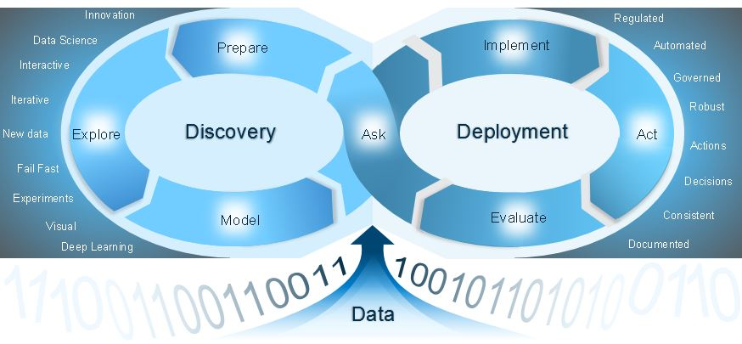

*2.2 Embedding Analytics as core to the organization*

According to the survey, 39% believe that analytics is core to their business, and is used both strategically and tactically, and a further 35% believe that analytics is used in their organization on a tactical basis for projects. That said, however, only 38% are clear that they have a philosophy of data-driven decisions across their organization.

Figure 3: Analytics Use and Role

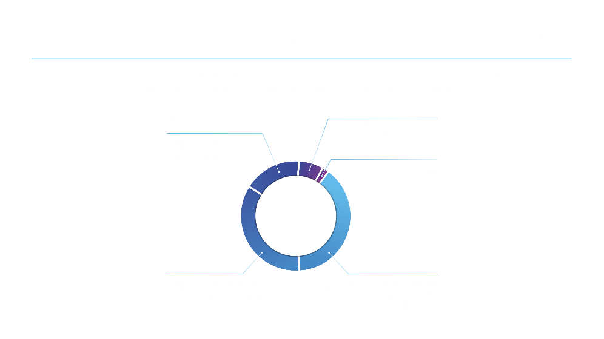

Perspectives also vary across key roles. Data scientists were the most optimistic about the use and deployment of analytics, and business sponsors the least, with IT decision-makers in the middle. This may say more about the relatively limited overview of data scientists: most are engaged only in approved analytics undertakings, while business sponsors are aware of requests that do not receive approval.

One key finding is that organizations that are project-based are still thinking in terms of ‘analytics initiatives’. By contrast, organizations that have genuinely embedded analytics have placed it at the heart of the operating model, often by the use of an analytics platform to improve access to data, foster collaborate cross functions/departments and make analytics an embedded part of the organization’s DNA.

For these organizations, analytics is simply a part of how they do business, a core part of how they operate. There is no such thing for them as an ‘analytics project’: All projects are analytical and data-driven.

**3. A foundation for Success**

With an iterative framework in place, and the understanding that an organization that have genuinely embedded analytics at the heart of the operating model, the need for a solid foundation to foster success is born. Establishing an analytics platform at the core of operation, designed to foster the analytical lifecycle framework, can deliver the necessary foundation and building blocks, cross traditional silos, for analytics success.

*3.1 The benefits of an Analytics Platform*

Across all roles, reducing the time and effort required for data preparation was cited as the number one benefit expected from platforms. This was followed by greater confidence in decisions, through being able to trust insights, and faster time to insights.

Figure 4: Benefits of an Analytics Platform

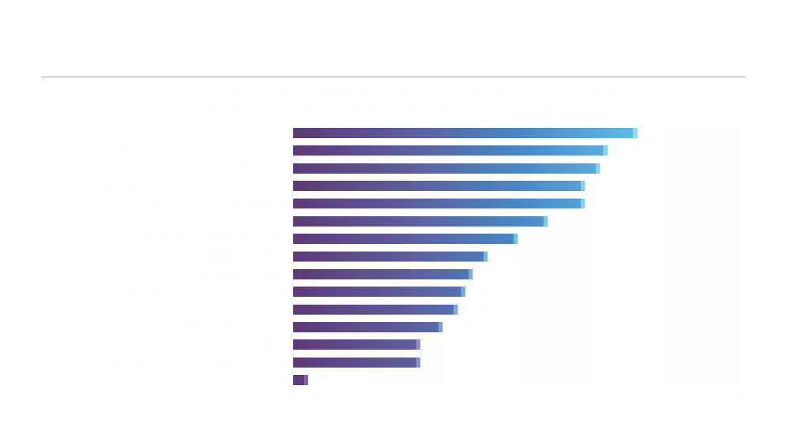

**4. The Value of Analytics**

The real experts of Analytics are very often not the decision makers in a company and the cost of putting analytics into action can often be a totally different game on real data and operational environments.

Technology and Programming skills are important, so are statistics and analytics skills. But without Business and Industry knowledge, the value of technology and analytics skill for an organizations outcome fade. And never the less, if there are no real communication skills at hand, succeeding with analytics and innovation can often be a hard and cumbersome path.

*4.1. Understanding the true value and cost of analytics.*

Back in 2006 Netflix announced a famed machine learning and data mining competition "Netflix Prize" with a $1 million award, finally claimed in 2009 by the winning team that made an improvement performance of 10%. However, they never adopted the winner, but another participant with solution of 8.43% improvement in RMSE. Simply put, 1.57% difference was not meaningful enough to bother, given the additional work it required to implement. An innovation and gain can often be trapped in a cost creep, regardless of it being the accessibility of data, quality, hours to develop or effort to train and maintain.

*4.2 Communication.*

Like the acquired insights in a data scientist brain does not bring any value to the company before it’s operationalized, the ideas of innovation with analytics will hardly ever see the light without decisionmaker understanding. And an analytical result of “0,42” can mean a whole lot for the data scientist, but at a glance mean totally nothing to the industry specialist. The skill of communication is far often the most under developed and under estimated skill of success with analytics.

**5. Succeeding with Analytics**

Experiencing organization looking to succeed with analytics for over a decade, there is no question that the way that organizations and individuals are thinking about analytics has changed dramatically just the last few years, and it will (and have to) continue to change. Both maturity, competence and confidence have grown across all sectors. Discussions are far less hypothetical and now driven by real experience and sometimes also fear. Some have had to learn the hard way by being challenged by far more analytics mature organization, often less experienced. Others have had more time and are well on their way to moving through the stage of ‘analytics projects’ and into ‘analytics as business’. And some does not want to understand that the train has left the train station.

*5.1 People, Process & Technology*

Succeeding with analytics is very much about collaboration, communication and operation in an iterative lifecycle fostering automation and cohesiveness designed to fail fast, adjust and deploy into operation as efficient and timely as possible and with as little interaction of manual work as possible.

For this success to take place it is key for the organizations not only to have the right people and skill but also to foster a culture of innovation cross business areas, roles, and skills. Having an iterative process/framework like the analytical lifecycle in place can reduce barriers, foster collaboration and reduce time spent on the individual phases of the cycle.

Organizations need to have the freedom to choose languages, tools, data (in different shapes/forms), analytical techniques and environments because this is what drives innovation and creativity. This provides an open space to try things out, to tackle new challenges, to explore the data and see what answers it holds. A wide range of employees need to be able to take advantage of all these choices, regardless of their analytic skillset. However, if there are not controls in place, analytic chaos can quickly creep up on an organization. Controls are necessary to provide trust in the data, which is critical, because if you lose that, it’s hard to get it back. Businesses have to trust the results of models are accurate and that the models will continue to perform over time. How data is used and that it complies with GDPR requirements is key to not loose trust. As a result, transparency, governance and security are essential. And controls become even more critical as organizations scale their analytic efforts. Limit things to much and value is hard to attain, open things to much and trust is easily lost. In other words, too much choice, and chaos reigns. Too much control, and innovation ceases to flourish. Choice and control are inter-connected but one doesn’t have to be sacrificed for the other. What’s critical is that there be the necessary balance for organization in order to execute on the analytic strategy to attain tangible results.

Succeeding with getting analytics into action, organization can truly benefit of an analytics platform as a foundation that has the necessary technical and functional capabilities to support the needed diversity of choice in balance with the necessary control. On the contradictory, by not having a tightly integrated platform as the foundation for the complete analytical lifecycle, one loses the benefit of platform embedded governance providing that balance between choice and control. Looking at it from a bottom-up: By establishing an Analytical Platform to access any data in any format, explore for insight, share and collaborate cross disciplines, build, challenge and validate analytical models, automatically publish to operational use, track performance, tune, challenge and adjust. But utilizing embedded intelligence and governance to maintain compliance, confidentiality and control throughout the whole lifecycle. All based on a framework well known to the organization, that fosters for collaboration between roles, skills and responsibilities of diverse talents in the organization. That’s analytics in action!

**6. What about the road ahead?**

What we know for sure is that we for sure don’t know, what the future holds. However, looking at the directions and where the focus of effort is put in development of analytical tools and platforms we can get a peek at the direction and opportunities of where things are heading.

*6.1 Reimagination and Rescoping of Innovation.*

Analytics is driving a reimagination and rescoping of innovation. Employees of the future will through the support of automation rather focus on a set of tasks rather than jobs. Analytics will pave the way for employees with portfolio of capabilities as they are increasingly augmented by smart and contextual information.

The path of the future is yet to be seen, however, the trends shaping the future are here. As we talked about an analytics lifecycle framework, the future is about intelligent automation. Yes, there will be new algorithms built. But by just imagining a world where we are applying the algorithms and techniques already known throughout the work with analytics we can achieve a totally new and automated experience.

An AI recommendation engine in your analytics platform can suggest and guide throughout the entire analytical lifecycle. Like suggesting what data you should look at based on task at hand, metadata and what other experts in your company are doing. The platform suggests how to join the data for you and based on your task what variables that has an impact. What models to use can be suggested and tested and the AI engine suggest the better fit for the case at hand. Applying analytics on the development of analytics are already starting to change the game.

*6.2 Interpretability for efficiency and explainability – xAI*

The nature of Machine and deep learning is that it is from hard to impossible for a human to explain the reasoning of the outcome of the built model. In many industries like e.g. Financial Services and Government this can exclude the use of AI, due to requirements to be able to fully explain an outcome of an analytical model. However, by adding explainability to the content of an AI model can give valuable and necessary insight which in turn can open for usage in new areas. Second, this also has a major impact on the process of development of AI models.

Having the underlying platform support data scientist with feedback of e.g. what parts of an image that is significant for the identification of an object can quickly give user feedback crucial for both understanding and time. If your military Tank detection model outlines the background tree as significant to the classification, you probably need to retrain your machine learning model on a broader set of data where not all the Tanks were in a forest, before you put it to motion.

*6.3 Containerization and Serverless Architecture*

Dynamic allocation of necessary resources when you need it is a gamechanger for the future of analytics. Virtualization and Cloud infrastructure delivered the opportunity to leverage underlying infrastructure cross systems, solutions and even companies. Also the containerization together with a micro service architecture paves the way for a continuous forward approach, of your complete platform. Whether it is the results of your effort or the platform itself, big bang upgrades is no more. A solution leveraging analytical insight can get an updated analytical model deployed live and the platform itself can get new techniques and functionality upgrades without big projects and downtime.

For number crunchers, data scientist and business user/consumers, this opens the opportunity to run more analytics on more data, with the latest functionality with a faster time to market, not compromising on governance and control. For many organization IT has often been seen as a huge cost and hence often become the bottleneck due to limited budget and resources. This new technology paves the way for a more automated and self-governing platform adapting itself to the requirement of the organization within the rules, governance and control defined.

Containerization as the evolvement of virtualization technology brings agility to the next level. Analytical platforms can automatically instantiate the necessary capacity by itself. Where we previously often pre-acquired capacity we now start to see adoption of platforms using intelligence to decide if an expanded capacity is of value to the analytical task at hand. From here it is a small step to have intelligence within platforms self-govern and justify if capacity expansion is within budget and broking on capacity becomes a reality. Imagine your analytical platform broking capacity on your behalf cross private and/or public cloud providers, then executing your job at a best cost/value. This is very much like having intelligent systems putting your electric car to charge when the electricity is cheapest from the best power supplier at amps that gives you the best power grid rental cost. How cool is that!